Accessibility ID Report — CarRental
Date: 28.06.2026 20:34 | Platform: ANDROID

Element ID | Page | Type | Label / Text | Value | Resource ID | Status | New Status | AI Suggestion
CarRental_element_1 | SearchActivity | ViewGroup |  |  | facet_with_bui_booking_header_toolbar | Unique ID |  | {  "key": "facetWithBuiBookingHeaderToolbarContainer",  "androidValue": "facet_with_bui_booking_header_toolbar",  "androidType": "id",  "iosValue": "facet_with_bui_booking_header_toolbar",  "iosType": "accessibilityId"  }
CarRental_element_2 | SearchActivity | TextView | 1 | 1 | bubble | Unique ID |  | {  "key": "bubbleLabel",  "androidValue": "bubble",  "androidType": "id",  "iosValue": "bubble",  "iosType": "accessibilityId"  }
CarRental_element_3 | SearchActivity | TextView | Search | Search | navigation_bar_item_large_label_view | Unique ID |  | {  "key": "navigationBarItemLargeLabelViewLabel",  "androidValue": "navigation_bar_item_large_label_view",  "androidType": "id",  "iosValue": "navigation_bar_item_large_label_view",  "iosType": "accessibilityId"  }
CarRental_element_4 | SearchActivity | ImageView |  |  | facet_entry_point_item_icon | Duplicate ID | ID Must Be Added (Waiting Dev) | imageview_icon
CarRental_element_5 | SearchActivity | ImageView |  |  | facet_entry_point_item_icon | Duplicate ID | ID Must Be Added (Waiting Dev) | imageview_icon
CarRental_element_6 | SearchActivity | ImageView |  |  | facet_entry_point_item_icon | Duplicate ID | ID Must Be Added (Waiting Dev) | imageview_icon
CarRental_element_7 | SearchActivity | ImageView |  |  | facet_entry_point_item_icon | Duplicate ID | ID Must Be Added (Waiting Dev) | imageview_icon
CarRental_element_8 | SearchActivity | ImageView |  |  | navigation_bar_item_icon_view | Duplicate ID | ID Must Be Added (Waiting Dev) | imageview_icon
CarRental_element_9 | SearchActivity | ImageView |  |  | navigation_bar_item_icon_view | Duplicate ID | ID Must Be Added (Waiting Dev) | imageview_icon
CarRental_element_10 | SearchActivity | ImageView |  |  | navigation_bar_item_icon_view | Duplicate ID | ID Must Be Added (Waiting Dev) | imageview_icon
CarRental_element_11 | SearchActivity | ImageView |  |  | navigation_bar_item_icon_view | Duplicate ID | ID Must Be Added (Waiting Dev) | imageview_icon
CarRental_element_12 | SearchActivity | TextView | Stays | Stays | facet_entry_point_item_label | Duplicate ID | ID Must Be Added (Waiting Dev) | stays_label
CarRental_element_13 | SearchActivity | TextView | Car rental | Car rental | facet_entry_point_item_label | Duplicate ID | ID Must Be Added (Waiting Dev) | car_rental_label
CarRental_element_14 | SearchActivity | TextView | Taxi | Taxi | facet_entry_point_item_label | Duplicate ID | ID Must Be Added (Waiting Dev) | taxi_label
CarRental_element_15 | SearchActivity | TextView | Attractions | Attractions | facet_entry_point_item_label | Duplicate ID | ID Must Be Added (Waiting Dev) | attractions_label
CarRental_element_16 | SearchActivity | TextView | Saved | Saved | navigation_bar_item_small_label_view | Duplicate ID | ID Must Be Added (Waiting Dev) | saved_label
CarRental_element_17 | SearchActivity | TextView | Bookings | Bookings | navigation_bar_item_small_label_view | Duplicate ID | ID Must Be Added (Waiting Dev) | bookings_label
CarRental_element_18 | SearchActivity | TextView | My account | My account | navigation_bar_item_small_label_view | Duplicate ID | ID Must Be Added (Waiting Dev) | my_account_label
CarRental_element_19 | SearchActivity | Button | Enter a pick-up location |  |  | Missing ID | ID Must Be Added (Waiting Dev) | enter_a_pick_up_location_btn
CarRental_element_20 | SearchActivity | Button | Pick-up 29 Jun 10:00, Drop-off 02 Jul 10:00 |  |  | Missing ID | ID Must Be Added (Waiting Dev) | pick_up_29_jun_10_00_drop_off_02_jul_10_00_btn
CarRental_element_21 | SearchActivity | Button | Enter the driver's age |  |  | Missing ID | ID Must Be Added (Waiting Dev) | enter_the_driver_s_age_btn
CarRental_element_22 | SearchActivity | View | Selected, you will return the car to the same location |  |  | Missing ID | ID Must Be Added (Waiting Dev) | selected_you_will_return_the_car_to_the_same_location_container
CarRental_element_23 | SearchActivity | ImageView | Messages |  |  | Missing ID | ID Must Be Added (Waiting Dev) | messages_icon
CarRental_element_24 | SearchActivity | ImageView | Notifications |  |  | Missing ID | ID Must Be Added (Waiting Dev) | notifications_icon

📸 Screenshot
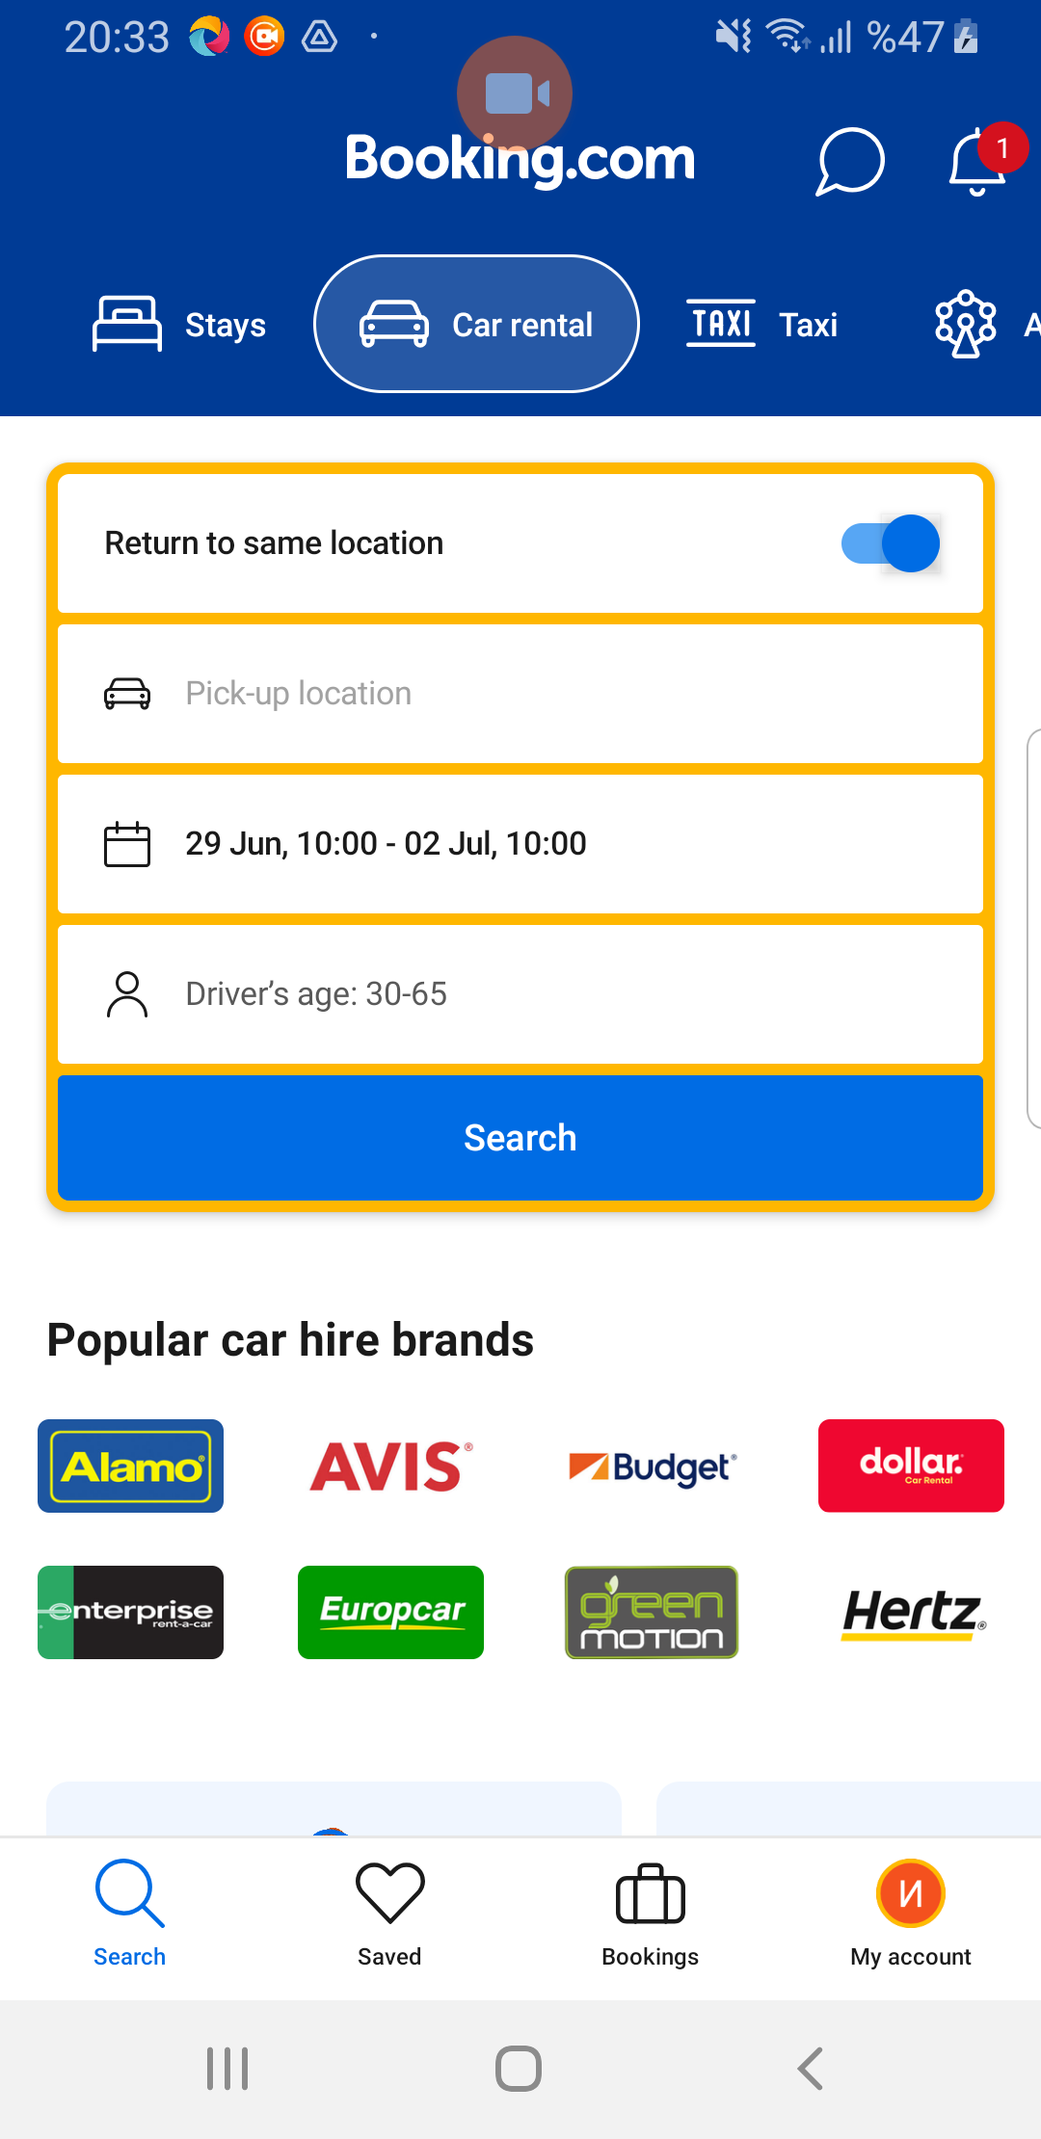
CarRental page screenshot

